
Copyright © All rights are reserved by Zakaria Toubi1
International Surgery and Case Reports

Open Access
Research Article

Atypical Presentation of Brodie’s Abscess in The Mandibular Condyle: Diagnostic and Therapeutic Challenges

Zakaria Toubi1*, Ahmed Enneffah2, Nouhaila Tarhzaz1, Dounia Kamal1, Mohamed Nouredine El Amine
*Corresponding author: Zakaria Toubi, Department of Reconstructive and Maxillofacial Surgery, Hassan II University Hospital of Fez, Sidi Mohamed Ben Abdellah University, Faculty of Medicine, Pharmacy, and Dentistry, Fez, Morocco.
Citation of this article: Zakaria Toubi, Ahmed Enneffah, Nouhaila Tarhzaz, Dounia Kamal, Mohamed Nouredine El Amine ELALAMI. (2025) “Atypical Presentation of Brodie’s Abscess in The Mandibular Condyle: Diagnostic and Therapeutic Challenges.”, International Surgery and Case Reports. Scholix Publishers, 1(2); DOI: 10.2026/IISCR/007

Received: May 05, 2026
Accepted: May 10, 2026
Published: June 01, 2026

Abstract:
Brodie’s abscess is a rare form of osteomyelitis, typically affecting long bones. Its occurrence in the mandibular condyle is extremely uncommon, often leading to diagnostic challenges and delays in treatment. We present our case of a 22-year-old female who consulted for facial pain and chronic trismus one month after a wisdom tooth extraction. Imaging, including CT and MRI, revealed an osteolytic lesion in the right mandibular condyle, which was consistent with Brodie's abscess. The patient was treated with intravenous ceftriaxone and metronidazole for 6 weeks, with total resolution of symptoms. The case highlights the importance of considering Brodie's abscess in refractory jaw infections that do not respond to standard therapy. Early imaging and awareness are essential for diagnosis and successful management early.
Key words: Paresthesia, Nerves, Sensory Loss, Vitamin B12, Health

of orbital bone defects. PEEK offers biocompatibility, lightweight properties, and radiolucency, while PMMA is renowned for its mechanical strength and ease of manipulation. Our prospective study aims include evaluating the durability and effectiveness of these materials, developing a standardized 3D reconstruction protocol from imaging data, and designing patient-specific implants through 3D printing technology. We will assess clinical outcomes regarding functional recovery and aesthetic results in patients receiving PEEK and PMMA implants, alongside enhancements in surgical techniques to minimize operative time and improve recovery. This prospective study aimed to use of 3D printing to reconstruct maxillofacial bone defects resulting from various injuries and assessment associated complications, evaluation and recovery experience and assessment of quality of life after operation
Materials & methods: A study at the Military Hospital in Sana'a, Yemen, found maxillofacial fractures in six patients who underwent maxillofacial reconstruction using 3D printing technology. The patients had previously undergone unsuccessful traditional treatments. The study involved preoperative assessments, CT scans, and functional evaluations. Custom 3D printed implants were designed using GOM and ATOS, and surgical procedures were performed under general anesthesia. PEEK and PMMA implants were used for craniofacial augmentation and reconstruction for our patients.
Results: A group of patients aged 20-43 years, with a mean age of 28.8 years, experienced pain, aesthetic deformity, limited mouth opening, difficulty eating, and bacterial infections. Causes included G.S.I , RTA , bomb explosion, and falls from height. Fractures occurred in various areas, with 83.3% resulting in a compound fracture, and 16.7% had simple and maxillary sinus fractures. The study found that all patients had unilateral fractures, with 33.3% having segmental fractures, 66.7% having displacement, and 50 having tripod fractures. Debridement operation was performed in all patients, with bone grafting and ORIF performed in 83.3%. Instability, insufficient, and infection were the most common reasons for failure. The study found that 66.6% of patients and physicians were satisfied with the results, while 83.3% reported excellent quality of life, with 83.3% of patients exhibiting good eating, speaking, social interaction, and emotional well-being.
Conclusion: This study highlights the potential of 3D printing technology in enhancing the outcomes of maxillofacial bone defect reconstruction by use PEEK and PMMA materials , especially in patients with prior treatment failures.
Keywords: bioceramics; maxillofacial bone defect; reconstructive surgical procedures; three-dimensional (3D) printing technology; PEEK; PMMA

to confirm the diagnosis. Blood, lymph node and bone marrow samples are taken for tests to identify a specific disease. The appearance of new tests is not rare because they are needed to determine the diagnosis as precisely as possible.
Keywords: blood; immunity; ige; pain; health
Introduction
Oral diseases, such as dental caries, periodontal disease, and oral cancers, contribute significantly to global morbidity. Dental caries alone affects approximately 2.3 billion people worldwide, making it the most prevalent chronic disease (Kassebaum et al., 2017). These diseases often go undiagnosed until later stages, leading to irreversible damage. Traditionally, diagnosis and treatment in dentistry have relied heavily on the clinical judgment of dental professionals. However, recent advancements in Artificial Intelligence (AI) offer promising solutions for early detection, improved diagnosis, and personalized treatment plans, transforming the landscape of dental healthcare.

AI refers to the development of systems capable of performing tasks that typically require human intelligence. In dentistry, AI applications are focused on automating and enhancing processes such as image analysis, disease prediction, and treatment planning. This article reviews the role of AI in diagnosing and managing oral diseases, highlighting significant advancements, clinical applications, and the challenges and ethical considerations involved in its integration into dental practices.
Keywords: artificial intelligence; oral diseases; machine learning; dental diagnostics; ai in dentistry; oral health; disease prediction; smart diagnostics; deep learning; ai algorithms; dental imaging; ai-based treatment planning.

nflammatory cells play a role in several steps of idiopathic pulmonary fibrosis pathogenesis (IPF). We aimed to evaluate the predictive value of peripheral blood cell (PBC) counts and inflammation indexes in the prognosis and mortality of IPF.
Materials and Methods:
A total of 155 patients with IPF followed between 1 Januay 2016 to 1 January 2023 were evaluated retrospectively. The baseline values and annual changes for pulmonary function tests and the PBC counts, ratios, and inflammation indexes (leukocyte, neutrophil, platelet, monocyte, lymphocyte, RDW, NLR, dNLR, PLR, MLR, SII, SIRI, AISI) were recorded. The relation between PBC, ratios, and inflammatory indexes with functional parameters (FVC, DLCO, 6 MWT, GAP stage) and mortality were examined.
Results:
It was found that baseline RDW and neutrophil count were negatively correlated with survival time. The prognosis was worse in patients who had a RDW> %13.6 and a neutrophil count>5.26×10⁹/L ( p=0.0005, p=0.037 ). Significant correlations were observed between baseline peripheral blood cell counts, ratios, and index values (leukocyte, monocyte, neutrophil, platelet, monocyte, lymphocyte, NLR, PLR, MLR, SII, SIRI, AISI) and, functional parameters (FVC, DLCO,6 MWT, GAP stage). However, there was no significant correlation between the yearly changes.
Conclusions:
Increased neutrophils and RDW may be related to the poor prognosis in IPF. Peripheral blood cell counts and inflammatory indices may provide useful information in identifying patients with worse functional status.
Keywords: Idiopathic pulmonary fibrosis; inflammation indexes;mortality; prognosis

is critical for developing “explicit memories” —clear, conscious, records of what really happened—gets worn down by the body’s stress response. Cortisol and other glucocorticoids weaken synapses in the brain and inhibit formation of new ones. When the hippocampus is weakened, it’s much harder to produce new neurons and thus make new memories. As a result, the painful, fearful experiences the sensitized amygdala records get programmed into implicit memory, while the weakened hippocampus fails to record new explicit memories.
When this happens, you wind up with no real memory of what set you off to begin with but with a very clear sense that something bad—something very bad—is happening. We have to transcend the body to change the body, overcome the ego to change the ego. We must become pure awareness and going beyond time, forget the known reality and go into the unknown and observe the infinite possibilities and tune into the possible realities, because if we think about them, in the quantum universe they already exist

Keywords: neuroscience; deep skills; recognition memory; spatial memory, physical activity; psychomotor skills; LagreeFitness, mental health; rehabilitatio; cognitive exercise; massage; exercise physiology; neurophysiology; psychology; psychophysiology

Introduction

Brodie's abscess, first described by Sir Benjamin Brodie in 1832, is an uncommon form of subacute osteomyelitis characterized by a localized collection of pus within the osseous tissue, typically limited by granulation tissue [1]. The condition predominantly involves the metaphysical regions of long bones like femur and tibia [2]. The involvement of the condyle of the mandible by Brodie's abscess is exceedingly unusual and therefore presents a very serious diagnostic dilemma. Imaging studies, particularly MRI, are of paramount significance, showing typically lytic lesions with sclerotic rim [3]. Confirmation diagnosis often still requires histopathologic study and microbiologic evaluation. We report an unusual case of Brodie's abscess of the mandibular condyle, emphasizing the value of clinical suspicion in a chronic trismus case, and the necessity for appropriate imaging and early management.

Case presentation:

A 22-year-old female with a history of recent wisdom teeth extraction, presented to our facility with an on-month history of right sided
facial pain, trismus and right mandibular later deviation. Symptom onset was acute and was accompanied by a subjective fever. The patient reported no past medical issues, including no history of diabetes as well as no tobacco or illicit substance use. After not getting relief from pain in her face, she came for treatment in the emergency department with exacerbation of her symptoms. The examination revealed a 2 cm × 2 cm area of intense tenderness localized to the right temporo-mandibular joint, with a maximum mouth opening of less than two finger widths (figure 1). The initial evaluation revealed stable vital signs, with no fever or leukocytosis.

Figure 1: Frontal view of the patient showing a limitation of mouth opening under two finger widths
A Panoramic dental –X ray showed a right osteolytic lesion focused on the infra-condylar region of the mandible. A computed tomography (CT) scan with contrast of the facial bones showed the presence of an osteolytic process in the medullary portion of the mandibular condyle, measuring 13 mm similar to Brodie’s abscess (figure 2).
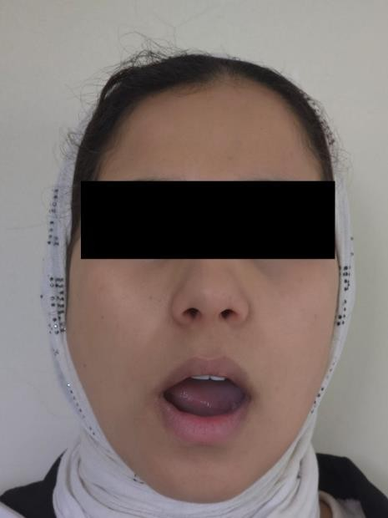
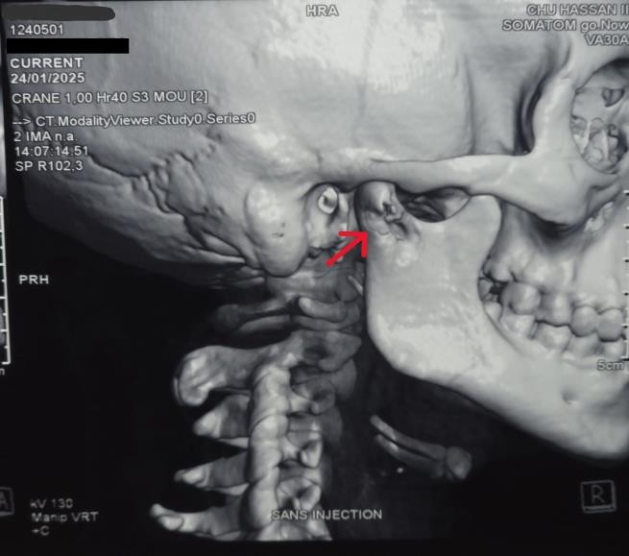

Figure 1: 3D reconstruction scan showing an osteolytic process of the right mandibular condyle Otherwise, an MRI of the TMJ for a better description of the osteolytic process was done and showed a T1 iso-intense and T2 hyper intense signal localized on the right condyle of the mandible and responsible of a lysis of the head and the neck of the right side of mandible with no enhancement of the temporomandibular joint (figure 3). temporomandibular joint (figure 3).

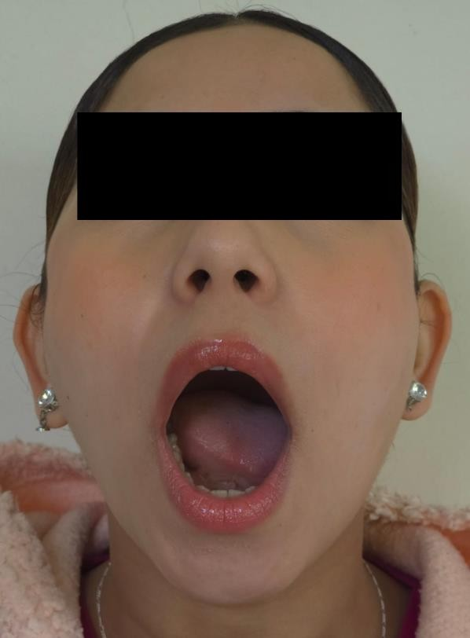
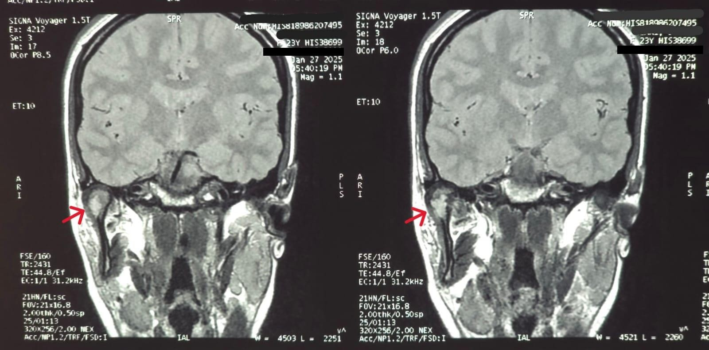

Figure 4: Frontal view of the patient showing normal mouth opening 6 weeks after treatment

Figure 3: Coronal T1-weighted image showing an osteolytic process of the right condyle Empiric intravenous therapy with ceftriaxone and metronidazole was started to target gram positive and gram-negative bacteria, as well as the anaerobes commonly found in the oropharynx, for a total duration of six weeks. The patient achieved substantial symptom alleviation over the following days, culminating in the total eradication of facial discomfort and trismus by the seventh day of antibiotic therapy. At this juncture, during the sixth week of treatment, the patient remained afebrile, exhibited a normal white blood cell count, and presented no symptoms. (Figure 4).
Discussion:

Brodie's abscess is a well-documented but uncommon type of subacute osteomyelitis, classically described in the metaphysis of long bones like the femur and tibia [2]. Its occurrence in the mandibular condyle, as observed in this case, is exceptionally rare. It poses a peculiar dilemma for clinicians because of the challenge of distinguishing it from other jaw conditions like temporomandibular joint disorders and neoplastic jaw lesions [4].

The etiology of Brodie's abscess is theorized to be hematogenous bacterial seeding or contiguous spread from a nearby infection, e.g., odontogenic. The most frequently cultured organism is Staphylococcus aureus, but negative cultures are not infrequent, as reported in several series [5].

The absence of elevated inflammatory markers and the insidious onset of symptoms in this case are typical of the classic presentation of Brodie's abscess [6]. Most patients have few systemic symptoms or are febrile, and this can cause delays in diagnosis as well as be a contributing factor to failures in treatment in the event of misdiagnosis. Additionally, the mandibular condyle's relatively poorer vascularity can be a factor in the chronicity of infection and make treatment more complicate. Therefore, early and appropriate imaging, as well as histopathological examination where possible, plays a key role in making the proper diagnosis and having the optimal outcome of treatment.

The patient, in this case, presented with progressive limitation of mouth opening 1 month after the dental procedure, which was initially managed with analgesics, providing only temporary relief. This reflects the difficulty in the diagnosis of Brodie's abscess because its symptoms also imitate those of more common oral infections that also cause trismus. Imaging studies, particularly CT and MRI, are required for an accurate diagnosis. In our case, CT demonstrated an osteolytic lesion with periosteal reaction, which was also verified with MRI. Penumbra sign was found to be a very trustworthy sign for subacute osteomyelitis [7], one that holds the potential to reduce misdiagnosis rates in this realm [8]. MRI findings in our case were consistent with the classic description of Brodie abscesses in the literature [9].

Management of Brodie's abscess in unusual sites such as the mandibular condyle is not well established, and there is no standard protocol. Surgical debridement followed by antibiotic treatment has been described in the past as the gold standard in the management of Brodie's abscess [5]. In our case, all the surgical interventions have been refused by the patient, and hence we decided on long-term antibiotics to avoid recurrence.

The available antibiotic options for jaw osteomyelitis is primarily ampicillin and sulbactam [10]. Other medications like penicillin, cephalosporins, metronidazole, clindamycin, vancomycin, ertapenem, and carbapenems can also be used depending on the particular clinical case and susceptibility of the microorganisms [11]. There continues to be no consensus about the duration of antibiotic therapy for jaw osteomyelitis, with recommendations ranging from four to eight weeks [11].

Although curettage and bone grafting under surgery are typically performed in long bone infections [6], management of mandibular condyle Brodie's abscess is also complicated by the necessity of TMJ reconstruction in more advanced cases. Due to the structural significance of the condyle, maintenance of bone integrity and elimination of infection continue to be overriding concerns [12].

Conclusion:

This case emphasizes the need to have Brodie's abscess in the differential diagnosis when a patient has unexplained, chronic jaw pain or trismus, particularly in instances where analgesic treatment is not found to be effective. A consensus on the appropriate treatment for jaw osteomyelitis has not been achieved. Moreover, given that a Brodie abscess is uncommon in the mandibular condyle, there are no recommendations in the literature to guide management.

More studies and case reports are needed to develop more specific protocols for the treatment of Brodie's abscess in the mandibular condyle because it continues to be a rare and difficult entity to treat.

Conflict of Interest

The authors declare no conflicts of interest.

Authors' Contributions:

All authors participated in the patient's care and in the writing of the article.
All authors have read and approved the final version of the manuscript.

Funding acknowledgement:
The authors declare that no funding was received.

Ethical approval:
The authors declare that ethical approval was not required.

References:

1.Brodie BC. An Account of Some Cases of Chronic Abscess of the Tibia. Journal of the Royal Society of Medicine. 1832; 17: 239-49.
2. Ogbonna O, Paul Y, Nabhani H, et al. Brodie’s Abscess in a Patient Presenting with Sickle Cell Vasoocclusive Crisis. Case Reports in Medicine. 2015; 2015: 1-3.
3. Abdulhadi M, White A, Pollock A. Brodie Abscess. Pediatric Emergency Care. 2012; 28(11): 1249-51.
4. Zeller, Alexander-N., Neuhaus, Michael, Lafos, Marcel, et al. first description of a mandibular brodie abscess in a pediatric patient: case report. sn comprehensive clinical medicine, 2020, vol. 2, p. 1282-1286
5. van der Naald N, Smeeing DPJ, Houwert RM, Hietbrink F,Govaert GAM, van der Velde D. Brodie’s abscess: a systematic review of reported cases. J Bone Jt Infect. 2019;4:33–9.
6. Dharmshaktu, Ganesh Singh. Brodie's Abscess: Brief Review of Key Updates from the Year 2010. Journal of Orthopaedic Diseases and Traumatology 4(1):p 104-108, Sep–Dec 2020.
7. Shimose S, Sugita T, Kubo T, Matsuo T, Nobuto H, Ochi M. Differential diagnosis between osteomyelitis and bone tumors. Acta Radiol. 2008.
8. Oudjhane K, Azouz EM. Imaging of osteomyelitis in children. Radiol Clin N Am. 2001;39:251–66.
9. Marti-Bonmati L, Aparisi F, Poyatos C, Vilar J. Brodie abscess: MR imaging appearance in 10 patients. J Magn Reson Imaging. 1993;3:543–6.
10. Baur D, Altay M, Flores-Hidalgo A, et al. Chronic Osteomyelitis of the Mandible: Diagnosis and Management-An Institution’s Experience Over 7 Years. Journal of Oral and Maxillofacial Surgery. 2015; 73(4): 655-65
11. Dym H, Zeidan J. Microbiology of Acute and Chronic Osteomyelitis and Antibiotic Treatment. Dental Clinics of North America. 2017; 61(2): 271-82.
12. DSouza, M., Xu, J., John, E.S., & Parikh, P.D. (2017). Brodie abscess of the jaw: An unusual presentation of a rare complication of subacute osteomyelitis. Criminology, 4, 75.

